**IDENTIFICATION OF SHORTEST PATH FOR ELECTRIC VEHICLE CHARGING STATION AND TIME OPTIMIZATION**

**PRAKASH D**

**(CB.EN.P2AIE21020)**

**SUPERVISORS**

**Dr. JEYAKUMAR G Ms.G.Lavanya**

**Professor, Vice Chairperson Assistant Professor**

**M.Tech (Artificial Intelligence) – III Semester**

**21CS798 – Dissertation Phase I**

**Department of Computer Science and Engineering**

**Amrita Vishwa Vidyapeedam**

**School of Engineering**

**Coimbatore**

**IDENTIFICATION OF SHORTEST PATH FOR ELECTRIC VEHICLE CHARGING STATION AND TIME OPTIMIZATION**

**Research Domain:**Electrical Vehicle charging station location Identification and waiting time optimization using Genetic algorithm

**Problem Statement for Dissertation:**

Finding local charging stations are free and prioritize the vehicle timetable using big data storage techniques. Due to long charging time taken, identify the public station that is the closest, calculating the waiting time, and/or recommending a different station that is closer to charge.

Make the reservation, through message or utilize another form of communication.

**Expected outcome:**

* Easily find out nearest charging stations freely available.
* Prioritized vehicles will be allowed to get charge.
* This proposed system will improve EV’s battery life cycle.
* Waiting time will be reduced.

**Base Paper Identifications**

* Aala Kalananda Vamsi Krishna Reddy, Komanapalli Venkata Lakshmi Narayana, Meta-heuristics optimization in electric vehicles -an extensive review, Renewable and Sustainable Energy Reviews https://doi.org/10.1016/j.rser.2022. 112285
* Kramer, Bill, Sudipta Chakraborty, and Benjamin Kroposki. "A review of plug-in vehicles and vehicle-to-grid capability." 2008 34th annual conference of IEEE industrial electronics. IEEE, 2008.
* Efthymiou D, Chrysostomou K, Morfoulaki M, Aifantopoulou G. Electric vehicles charging infrastructure location: a genetic algorithm approach. EurTransp Res Rev 2017;9. <https://doi.org/10.1007/s12544-017-0239-7>.
* Yong, Jia Ying, et al. "A review on the state-of-the-art technologies of electric vehicle, its impacts and prospects." Renewable and sustainable energy reviews 49 (2015): 365-385.

***ABSTRACT***

The optimization of electric vehicles (EVs) utilizing meta-heuristics has arisen as the way to propelling state-of-the-art advancements, making ready for boundless reception, and reforming the flow transportation framework while lessening ozone-depleting substance discharges. The two factors that keep on obstructing the improvement of EVs are reach and cost. This study digs profoundly into the five significant EV enhancement regions: plan advancement, energy the board, ideal control, upgraded charging and releasing and steering. Methods for single-objective and multi-objective enhancement are examined and talked about. Following a broad survey of the latest works in every space, an investigation of numerical demonstrating, the development of goal capabilities, time management for charging and limitations is introduced. What's more, the different scientific, regular, and nature-roused advancement calculations (swarm-optimization, transformative, and recent meta-heuristics) are arranged in view of their fame. Their merits and detriments are then analyzed, similar to the different requirement taking care of procedures. This survey of the high level and redesigned variants of these meta-heuristics likewise gives a precise reference to EV streamlining utilizing wise calculations.

**Introduction**

***.New era in Transportation***

EVs Electric vehicles (EVs) are the way in to a supportable future as the world battles environmental change. As per the World Meteorological Association (WMO) articulation [1] on the

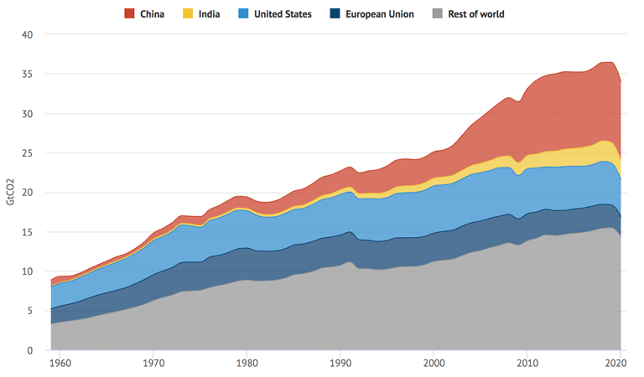

Figure .1. Global CO2 emission from fossil fuels by region, 1959 – 2020

condition of the Worldwide Environment in 2019, the normal worldwide temperature has expandedby almost 11.1°C over the pre-assessed normal in 2019. Other ozone depleting substances (GHGs) like N2O, CH4, and others have additionally arrived at new highs [2]. The best way to guarantee our manageability is to quickly change from petroleum derivatives to inexhaustible sources, as well as from customary assembling and transportation to cleaner, greener eco-accommodating innovation [3]. As per EPA appraises, the transportation and aeronautics enterprises might represent up to 30% of absolute worldwide ozone harming substance discharges [4]. (epa.gov). Figure 1 portrays the expansion in CO2 emanations from the transportation and avionics areas somewhere in the range of 1990 and 2020 (iea.org), with the anticipated pace of increment for the following twenty years at the ongoing pace of discharge showed in green. Figure 2 portrays how various areas added to CO2 discharges in 2018. (information kindness of "epa.gov"). Transportation represents around 20% of absolute emanations (barring flight), with discharges from power age positioning

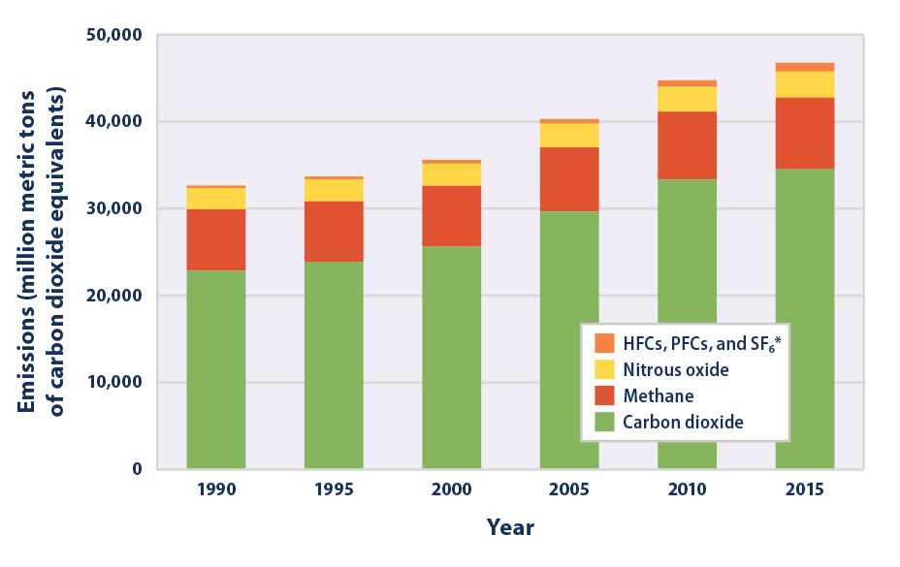

# Figure . 2. Global Greenhouse Gas Emissions

first. It is critical to take note of that these rates ought to be decreased to safeguard people in the future from the disastrous impacts of environmental change, notwithstanding the way that different regulations and goals have been ignored by states all the world [5]. The transportation business' conventional renewable and non-renewable energy source based drive frameworks should be supplanted with a cleaner, greener option [6,46,47]. Vehicles and trucks represent generally 80% of all contamination, with the excess 20% coming from different sources. Accordingly, scholastics and experts should foster other option, harmless to the ecosystem strategies for lessening discharges while as yet permitting the transportation area to really work.

***Growth of Electric vehicles, classifications and applications***

Electric vehicles (EVs) are critical to improving the transportation system because they are motorized via clean, renewable energy sources [7]. Furthermore, in period of moving back fuel and natural gas resources, EVs could be a lifesaver. While these arguments support the need for electric vehicles, they also emphasise the importance of extensive optimization and hybridization to ensure a smooth transition from traditional transportation to electricity. Because it might not be probable to create an electric vehicle that is apt for all area and uses, the question of whether an all type of electric vehicle are viable for the present working circumstances by available knowledge emerges. Despite the fact that there seems to be a complex problem here, there is actually a simple solution: one possibility is to hybridize cars so they can propulsion from both an electric motor and a conventional internal combustion engine (ICE) [8]. In contrast to conventional automobiles, these hybrid electric vehicles (HEVs) were designed with the electrical system's operation in mind, which

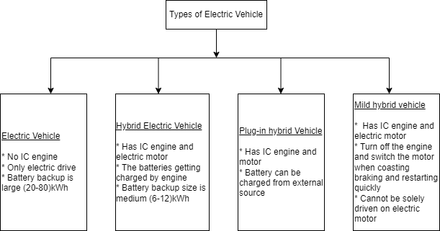

Figure 3. Basic classifications of Electric vehicles

reduces the frequency and conditionality of their requirement for propulsion assistance [9]. When the vehicle is in use, proper execution is essential for lowering emissions and guaranteeing that pollution is kept to a minimum. Figure 3 displays the many EV types. EV production, sales, use, and other aspects of the industry are all expanding at a startling rate [10]. The introduction of several more models each year indicates that the world is embracing EV-based mobility, according to the "Global EV sales report and growth trend for 2013-2018" (given by EV-Volumes.com). The use of EVs becomes more prevalent over time as more transportation sectors comply with strict rules and climate change strategies to combat rising pollution [11].

Long recharging times are still a problem that needs to be solved [12]. This is explained in the section below. To meet the demand for fast charging, many EV manufacturing companies are racing to improvement the quickest EV charging system, paying to no attention to the trouble of battery recharging. In the accounts for both the costly converters that must be installed in EVs and charging stations, as well as the pricy equipment that must be used to expedite battery charging. Rapid charging be able to difficult on the local distribution system since it necessitates extra adjustment because the power quality deteriorates as a result of the large amount of energy used in a brief duration of time. A thorough and effective planning strategy, coordinated charging, and a dynamic pricing strategy that allows customers the choice of choosing between rapid and regular charging with rates that change depending on the charging time are all required solutions to this complicated challenge. The stacking prerequisites of the nearby appropriation network should considered while coordinate, with environmentally friendly power being given the most elevated need during the daytime through a proficient dispatch framework [13]. The primary issues that must be resolved for EV optimization are shown in Figure 4. Users may become irritated and rethink converting to EVs due to a lack of EV options. The majority of consumers would be attracted to a extensive variety of EVs, whether 2-wheelers or 4-wheelers, with a marketing pricing structure for a number of application ranges, even in developing countries. Thankfully, a lot of companies and

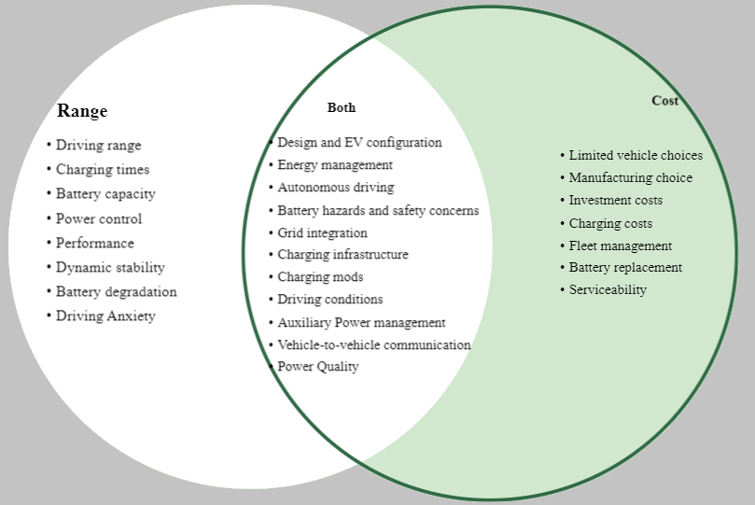

**Figure 4**. Relative data realistic of the vital areas of concentration for the advancement of EV innovations.

organizations, like Tata, Hyundai, MG motors, Hero motors, Bajaj auto and others, have already shifted to hybrid-electric and electric cars and bicycles. In greater anticipation investments in those technologies by enterprises and organizations, the price of these models has not yet fallen.

***Challenges in the optimization of EVs***

***Choice of optimization algorithm***

Finding the finest answer intended for a specific arithmetical representation is the most fascinating use of meta-heuristics, sometimes referred to as optimization algorithms. These algorithms employ an iterative initial guessing method that gets better with each search [16]. Inadequate knowledge of the training data and locations is needed. Even in systems with inequality and equality requirements, where machine learning approaches take longer and require a lot of training data, these algorithms can produce a practical yet ideal solution. The headway of multi-objective streamlining approaches, which can deal with the improvement of a few goals and yield arrangements that don't go against each other, is likewise imperative.

***Constraint handling mechanisms***

Goals are normally clear in the wellness capability of streamlining calculations, and at whatever point an imperative is disregarded (by the development of the pursuit specialist on the obliged/taboo region), a critical punishment is added to the wellness capability (utilizing a punishment factor approach), expanding its worth immediately so the calculation sees it as a non-ideal arrangement. The "constraint adjustment" method is another tactic, which involves rounding off or moving a constraint to a neighbouring viable area if a decision variable's placement on the constraint area breaches the constraint. Even if each methodology has pros and cons for certain optimization issues, it really depends on the analyst to choose the best techniques [14].

***Enhancement in EVs***

EV manufacturing technology is still in its infancy [15]. EVs still need to adapt to the current car transportation system in order to fully realise its utility because it is best suited for conventional systems. A considerable lot of these issues and difficulties can be taken care of with the utilization of man-made consciousness (simulated intelligence) and savvy processing procedures, and any lingering problems will eventually disappear. The primary problems and best remedies are listed in Table 1 [16]. The AI based intelligence based advances guarantee a solid and ideal arrangement with web access, which might be put away in a cloud data set to help other possible clients.

**Table 1**

Prominent EV issues and potential fixes.

|  |  |
| --- | --- |
| Problem Description | Adopting a strategy for the best outcomes |
| Design and production of EVs | Optimization methods (single and multiobjective) for the best design outputs without performance loss |
| Charge and discharge of EVs | Integrating renewable energy sources with efficient load dispatch for the local distribution network will result in the best planning and coordination. |
| Energy management | Meta-heuristics-based optimized driving cycles can increase the EVs' reliance on electricity while reducing the requirement for ICEs powered by fossil fuels. |
| EV control | Metaheuristics are used to modify a variety of controllers using optimal control strategies for the greatest operating performance. |
| Planning charging stations | A problem for determining the ideal position for charging stations can be built based on previous driving data. |
| Integration of sustainable power for EV charging stations | It is possible to create a multi-objective improvement model that considers both the discontinuity models related with environmentally friendly power sources and the charging patterns inspected. |

The quality of the answer improves as more data are obtained. With increased automation and mechanization, the field's reach appears to be expanding, and several technologies and methodologies based on SCT and AI have been created and studied in the past. A most huge area of examination in streamlining of EVs are reception of meta-heuristic-based improvement calculations and AI procedures to give versatile and dependable answers for a better EV advancements beginning with their assembling, plan, activity, and organization [17]. The viability of meta-heuristics in resolving any certifiable issues is all around outlined by "Goldberg's view (1989)" [18]. It declares that streamlining can go about as a reliable and compelling system to find the best reactions for most of circumstances with practically no earlier data on the arrangement prospects. Figure 5 shows Goldberg's perspective. The drawback of utilizing meta-heuristic optimization methods is that there is no assurance that the algorithmic solution chosen will be the best one that can be given the situation. More fine-tuning might be required to overcome the ambiguity in how meta-heuristics perform in both constrained and unconstrained circumstances. The following significant downside is the continuous clash that emerges from finding some kind of harmony between investigation (broadening of arrangements focused on worldwide hunt) and double-dealing (strengthening or exact restriction of arrangements focused on neighborhood search) [19]. Since the issue plans for upgrading electric vehicles (EVs) require a great deal of estimations, an exact arrangement that handles a ton of aspects, and various imperatives that limit the reasonability of the arrangements, the field of enhancement using meta-heuristics is a fabulous fit.

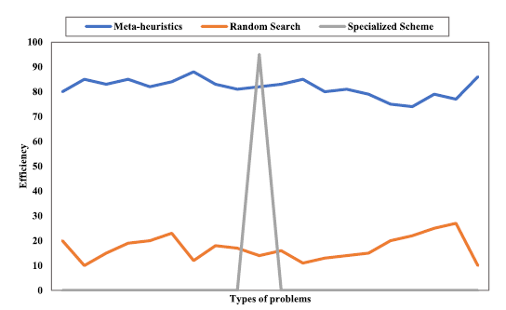

**Figure. 5.** A comparison of efficiency over various problems using Goldberg’s view.

The subject of EV optimization research has developed quickly over the previous ten years, with studies carried out all across the world contributing to this advancement.

***Motivation for the review***

This survey's motivation comes from the necessity for asset-saving innovations and successful asset the board for a cleaner, greener future. Electric vehicles (EVs) are a positive development in this present reality where contamination levels have crested and an energy emergency might foster over the course of the following couple of many years. EV technologies must be progressively enhanced and optimized as they develop into the new transportation and mobility mainstream. The fight against climate change is being waged by governments all around the world, and EVs and renewable energy have been at the forefront of this campaign. Our way of life, which is dependent on energy use, may benefit from the advancement of these technologies. To aid upcoming researchers, five solutions in the enhancement of electric vehicles (EVs) are recognized. A number of relevant and well-known optimization models are also provided, together with a summed up portrayal of their concern details. A variety of various EV validation driving cycles are also looked at and ranked according to how popular they are.

***An outline of the improvement in electric vehicles***

***Areas of optimization in EVs***

Here few regions where streamlining is conceivable in EV (EMS). Since any alterations or changes to the creation or plan of the vehicle are probably going to impact energy utilization, EMS is the way to fruitful enhancement. To increase fuel economy without reducing the performance of the EV, careful planning is necessary. Efficiency of energy use Optimization of size and control parameters, as well as the closed-loop parameters for scheduling charges, routes, charging stations, and energy storage, Best charge coordination with scattered systems Enhancing design to control torque stability, optimizing Li-ion battery modeling for the charging-discharging (bidirectional) control, integrating renewable energy, optimizing wireless charging, enhancing drive mode, supply-side management, Scheduling for EVs, braking control strategy optimization, and powertrain architecture optimization, among other things.

Each of these factors is divided into one of five primary categories, and the optimization models for each of the sub-categories within each of these categories are reviewed and analyzed. The top five categorization groups are listed below. Following enhancement of charging and discharging, optimization of design, energy management, control improvement, and route is performed.

***Procedure for optimization of EVs***

Process for optimizing EVs is a combined one, with arithmetical formulation of many factors that need to be optimized coming first. The researcher has access to a wide range of software and tools that they can use to create, improve, and evaluate the EV model. The goal of optimization is to either increase the usefulness or performance of a current design while taking extra factors into account, or it can be used to create a brand-new model based on the application. For superior outcomes that don't require any additional suppositions or alterations, it is preferable to keep this modeling as exact as possible while taking into account all the small factors. The following info graphic in Figure. 6 describes the optimization process.

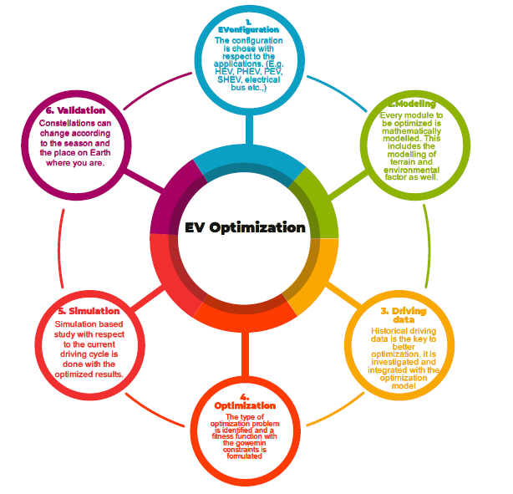

**Figure. 6.** EV optimization procedure.

***Energy management in EVs***

Most extensively concentrated on points in the field of EVs are energy management and strategies. The objective is to maximise EV performance while using less fuel and power without sacrificing performance [20]. Through the most effective coordination and load scheduling, renewable power sources for EV charging are integrated into significant study topics in EMS [21]. Other aspects include lowering emissions and increasing fuel efficiency, with the electrical system playing a significant role in propulsion [22].

***EV control optimization***

Control optimization aims to use the best possible control system to improve the performance of EVs. Additionally, it emphasizes characteristics related to driving comfort and safety, and it optimizes utilizing a man-made intelligence based regulator as per the energy the executives technique [24]. Additionally to them, optimization also incorporates stability improvement [25].

***Optimization of charging/discharging in EVs***

Research has been done on how to best optimize the charging and discharging systems while taking an EV charging demand improbability into account and heat generation in battery [26,28]. It is also investigated how to best coordinate charging and plan EV charging stations while taking into account how this would affect the local distribution network [27]. The incorporation of miniature lattices with the charging foundation challenges and the planning issues for charging stations for the best resource allocation are also investigated [28]. We offer the well-known optimization models with the various constraints. Other than energy management, the issue of EV charging is one that has received extensive research. The summed-up advancement model and the writing survey of the main 20 most-referred distributions are both provided. Throughout the course of recent many years, there has been a huge increment in the study on EV charging optimization, with the previous five years seeing a particularly large increase in publications. Figure. 7 depicts the yearly increase in publications on the optimization of EV charging and discharging. Figure. 8 depicts the main areas that need attention in order to optimize charging and discharging in EVs.

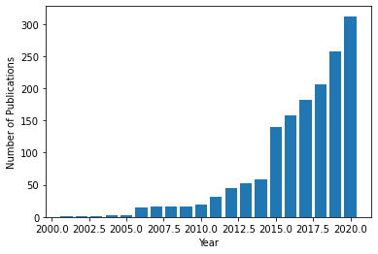

Figure 7. Growth in the distributions connecting with the advancement of

charging/discharging in EVs.

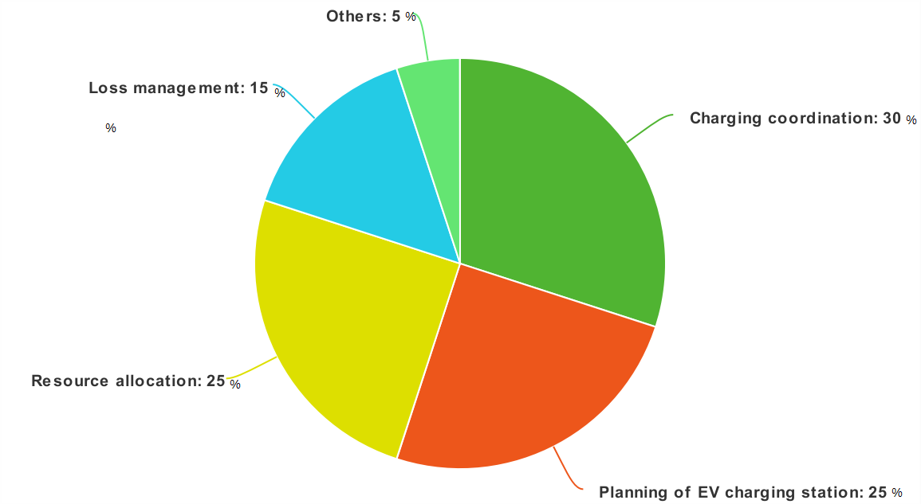

**Figure. 8.** Key areas of concentration inside the streamlining of battery management in EVs.

***Issues in selection of location of EV charging infracture***

In view of beginning objective (OD) information and the degree of EV entrance nearby, the ideal site for an EV charging station is merely a practical matter rather than an optimization problem. The optimum answer to this problem is the one that satisfies every need; cost, fit, or target functions are not necessary. After evaluating the location data, a number of locations are chosen as the optimum locations for the deployment. The sending is then upgraded for all reasonable situations that fulfill the different necessities, including the length of the course, any traffic guidelines, typical speed of the vehicles, and so on. The extent of EV penetration and the required number of stations are taken into account [29].

***EV route optimization***

The ideal course or the briefest distance between the source and objective destinations must be determined for EV optimum routing problems. The goal of route optimization is to use the available resources as efficiently as possible to go as quickly and efficiently as possible to the target [30]. Since driving and traffic conditions are critical, online improvement strategies have been proposed in the writing [31]. Recently, a lot of focus has been placed on optimised pre-set drive mode combinations that the driver can select from to save fuel usage. Fuel management in regard to course information is the subject of extraordinary examination, with enhancement empowering the decision of the best drive cycle [33]. The three drive mode enhancement strategies are coordinated drive mode with way arranging, course based drive mode advancement, and online drive mode streamlining [32]. The analysis of the well-known optimization models is followed by an assessment of the most-cited papers. The primary focus areas for the optimization of the EV route are shown in Figure 9.

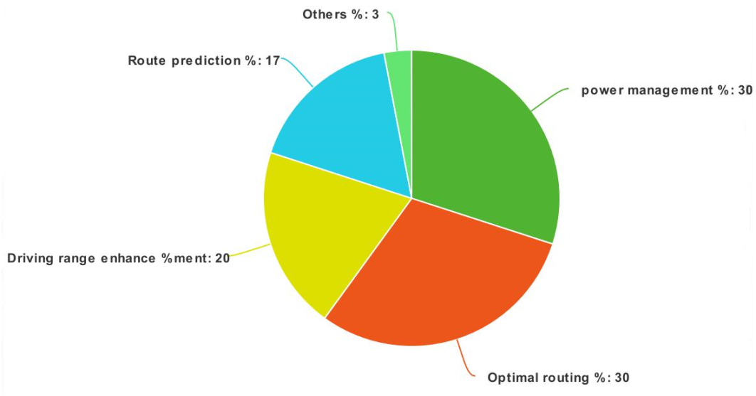

**Figure. 9.** Key areas of concentration inside the EV course enhancement.

***Future scope***

***Optimization algorithms and big-data analytics***

***Scope of meta-heuristics***

In spite of the fact that a number of new meta-heuristics and troubleshooterhave been discussed and ready to use, it's important to create complex, dependable systems. Combination of well-known reimbursement of conventional technique with new approaches or by planning crossover calculations while reducing the topological difficulty, it is possible make sure that upcoming researchers and practitioners have access to a wide variety of trustworthy and high-quality tools [35].

***Scope of real-time optimization****.*

Over the past three years, research has mostly focused on real-time EV battery management using meta-heuristics. Because vehicle-to-everything (V2X), GPS informations and real-time traffic are constantly being exchanged between the controller and database, optimization is projected to be a crucial part of control and EMS. A result of improvements in computer power is the increased execution of these computations and their implementation. The creation of meta-heuristics and artificial intelligence algorithms can lead to the creation of reliable optimization strategies that are impervious to environmental uncertainties and that produce accurate forecasts.

***Scope of big-data optimization****.*

A significant beginning in the correct heading could be given by the large volumes of information that shrewd networks and electric vehicles with IoT gadgets are gathering. The examination and handling of the large information gathered (through different information investigations) will be used to grow energy and control techniques for different electric vehicles. Plan to best strategies and siting of new charging stations or repositions available ones, plan smart charging arrangements and calculations in the direction of diminish the duration of charging times, work on the adequacy and plan ideal EMS and battery the executive's plans, further develop the EV load taking care of limit of the dissemination frameworks or es, and more [23].

***Scope of sales forecasting.***

By examining marketing figures and EV growth trends, it is feasible to design the optimal car models that are most suited to meet consumer needs and preferences. By 2035, the largest auto markets are predicted to switch to all-electric vehicles, with FCEVs, BEVs, and PHEVs accounting for greater than 75% of new car sales across the world. Current EV models' price and battery management system can be improved, which will boost sales of EVs more significantly. The use of meta-heuristics in a business examinations are vital to survey with gauge this business drifts and present an assortment of EV models for portability, travel, and operations needs. With more than $400 billion in ventures, enhancement strategies and meta-heuristics might be utilized to work on the plan and improvement of novel EV, associated, independent, and shared versatility ideas [36].

***Scope of charging station infrastructure planning***

***Scope of optimal battery management systems.***

Battery innovation is growing quickly because of significant enhancements in energy storage, solid state advances, bigger limits with better heat management, and so on [37,38]. Support learning and big data the executives can be utilized to build the driving style, charging recurrence, and general condition of the strength of these frameworks. Powerful charging and discharging plans can be made conceivable by integrating streamlining into battery management system frameworks, giving conveyance networks more noteworthy command over vehicle-to-lattice advances and expanding consumer loyalty [39].

**Scope of charging networks and charging infrastructure***.*

As electrical vehicles become the subsequent key transit objective, it is essential to enhance the obtainable charging infrastructure and optimize it to suit the charging requirements. To build better charging networks, it is vital that cooperation with regional grids be established, along with the appropriate charging rate fixing [40]. Metropolitan transportation frameworks, similar to transport for London's Charging Foundation Obtainment System, have defined an objective to build the quantity of charging offices to 1000 in 2020 [41, 42], with research focused on additional rising these numbers and streamlining to assume a significant part.

***Scope of hardware design and implementation****.*

Even though THD reduction in inverters [44], loss minimization in converters [43, 45], most advantageous design, and finance management, hardware design enhanced by modern meta-heuristics have be limited. Complex optimization methods and meta-heuristics be supposed to study and compared for a number of EV hardware fabrication. Additionally, optimization algorithms can be utilised to boost automation in manufacturing and for electric vehicles [23].

***Fully automated driving.***

A fully autonomous experience can be realized when various sensors, cameras, and radars are combined into a single, hydraulic management system with enhancement at its own. The clearest example of this is provided by "Waymo," an ex-Google self-driving car project that more sensors and enhancement to determine the finest driving and routing strategies after logging billions of kilometers in reenactment and a more number of miles on open streets [31].

***Scope of time management.***

Finding local charging stations is free and prioritizes the vehicle timetable using big data storage techniques. Due to long charging time taken, identify the public station that is the closest, calculating the waiting time, and/or recommending a different station that is closer to charge. To make the reservation, send a message or utilize another form of communication.